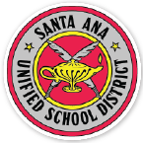 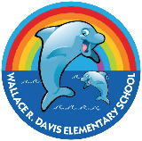Wallace R. Davis Elementary School  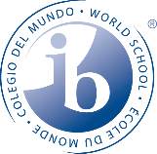
Vision:
As a Community School, Davis Elementary strives to cultivate a vibrant, respectful, inclusive and nurturing educational community in which all students flourish.

Mission:
At Davis Elementary, we are committed to fostering the social, emotional, and academic growth of every student through a rigorous, inquiry-based curriculum that engages and empowers our students as globally-minded learners. The curriculum includes a commitment to develop foundational academic skills in reading, writing and mathematics, as well as developing higher order thinking skills through transdisciplinary units of study. As a community-centered school, we nurture the whole child, supporting each child’s development in a safe, inclusive, and respectful environment in which all students flourish.

Core Values:
Community: We foster a strong sense of community by encouraging inclusivity, kindness, and mutual support among students, staff, and families.
Education: We are committed to providing a high-quality education that nurtures curiosity, promotes critical thinking, and inspires a lifelong love of learning.
Collaboration: We believe in the power of collaboration, working together as students, educators, families, and community partners to achieve shared goals and create a positive learning environment.
Respect: We cultivate an environment of respect where every individual is valued, diversity is celebrated, and all voices are heard.

Slogan: Brain Power Under the Water Tower!

Developed in 2023-24 by Davis Community School Leadership Council

